# **New National Biogas and Organic Manure Programme (NNBOMP) – 2020**

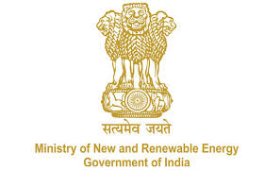

NNBOMP Information point (in case of doubts call us): 011-24360707; 24361920 Extn. 1047<https://mnre.gov.in/img/documents/uploads/dc65ef193ca9419f807441cfc193be3a.pdf>

**Implementing Agency Demand Request Form**

*Form number: P2.S1.l (e) ver. 1 (2020.05.10)*

*This form is developed to request the local bodies for assessing the demand in the areas assigned to them. The form contains the format for submitting the information.*

We request you to assess the demand for Bio-gas systems to be implemented under the “New National Biogas and Organic Manure Programme (NNBOMP)” of Ministry of New & Renewable Energy, in the areas assigned to you & submit the details in the performa below:

Please note: The last date of receipt of the form is XX.XX.XXXX (date.month.year).

|  |  |  |  |
| --- | --- | --- | --- |
| **S.no.** | **Category** | **No. of plants (Total)** | **No. of plants (toilet linked)** |
| 1 | General |  |  |
| 2 | Scheduled caste |  |  |
| 3 | Scheduled tribe |  |  |
|  | **Total** |  |  |

Date:

Sign